AI-Based Fall Detection & Early Risk Assessment System

SEMESTER TRAINING
REPORT

SUBMITTED IN PARTIAL FULFILLMENT OF THE REQUIREMENT
FOR THE AWARD OF DEGREE OF
BACHELOR OF TECHNOLOGY
(ELECTRONICS AND COMMUNICATION ENGINEERING)

SUBMITTED BY
BHUMI GUPTA
Class Roll No. 13/22
University Roll No. 2202325


Department of Electronics & Communication Engineering
DAV Institute of Engineering & Technology Jalandhar, India
(2022-2026)


O7 Services is an ISO 9001:2015 Certified company founded in 2015. They specialise in a variety of services including Web Development, Mobile Application Development, AI Bot, Machine learning Algorithm, Data Analytics, Cloud Computing, Cyber Security, Custom Software Development, UI/UX design, Hosting services, Digital Marketing, Registration of Domain Names with various extensions, AMC & MMC Services, Bulk SMS and voice calls. O7 Services offers advanced IT solutions supporting the entire business cycle - from consulting to system development, deployment, quality assurance, and 24x7 support. With over 10 years of experience, the company aims to form long-lasting strategic partnerships with clients, offering affordable prices, timely delivery, and measurable business results. Their headquarters are located in Jalandhar with a branch office in Hoshiarpur.
Some of the products developed by O7 Services include Vehicle Tracking System, Invoice Software, School Management System, Hospital Management System, Parents-Teacher Communication App, Fee Management system, Task Management System, Online Food Ordering App, Security App, Admission system, Inventory Software, and Car Servicing App. Additionally, O7 Services provides training programs including 6 Weeks/6 Months Industrial Training, Project-Based Training, Corporate Training, and Job-Oriented Courses Training, covering major IT trends such as Full Stack Development (MEAN/MERN), Flutter, Kotlin Android, Swift UI (iOS), Firebase, Python, Angular, React Js, Vue Js, Node Js, ASP.NET, .NET Core, PHP, Laravel, CodeIgniter, Software Testing, Cloud Computing, Blockchain, DevOps, Data Science, Artificial Intelligence, Machine Learning, UI/UX Designing, Digital Marketing, WordPress, Linux, CCNP, CCNA Security, Network Security, Cyber Security, MCSE, MCITP, Java, Spring, Hibernate, C/C++, Photoshop, Adobe Illustrator, Figma, CorelDraw and many more.
- +91- 8437365007, +91-181-5015007
- E-Mail: enquiry@o7services.com , hr@o7services.com
- www.o7services.com










Abstract

Falls are one of the major health risks for elderly people, patients, and individuals living alone. Delayed medical assistance after a fall can lead to serious injuries and life-threatening situations. To address this issue, the proposed project “Smart Fall Detection System using Computer Vision” is designed to automatically monitor human activities, detect falls in real time, and provide immediate emergency alerts for faster response and improved safety. The system uses computer vision techniques to analyze live video input and identify abnormal body posture or sudden movement patterns associated with falls. The captured video frames are processed continuously, and the posture angle of the person is evaluated to determine whether the individual is in a normal, warning, or fall condition. Multi-frame validation is implemented to reduce false detections and improve system accuracy. To enhance monitoring and record management, the system stores event details such as date, time, status, risk level, recovery condition, and alert information in an SQLite database. A web-based dashboard is integrated into the project to display live monitoring status, analytics, and emergency reports in an interactive and user-friendly manner. Privacy protection is also maintained by storing blurred fall images instead of raw images. The proposed system is developed using Python, OpenCV, Flask, SQLite, and related libraries for image processing and alert generation. This project can be effectively used in elderly care centers, hospitals, rehabilitation facilities, and smart home healthcare systems. The system aims to provide a low-cost, efficient, and intelligent safety solution capable of reducing response time during emergencies and improving patient monitoring through real-time automation.. In many situations, delayed medical assistance after a fall can increase the severity of injuries and may even become life-threatening. Continuous human monitoring is difficult in hospitals, homes, and healthcare centers; therefore, there is a growing need for an automated and intelligent monitoring system capable of detecting falls in real time and generating immediate alerts. To overcome these challenges, the proposed project titled “Smart Fall Detection System using Computer Vision” is developed to provide real-time fall detection, emergency response, and activity monitoring using modern computer vision techniques. The proposed system works by continuously capturing video input through a camera and analyzing human posture and body movement. Using image processing and posture angle calculation techniques, the system identifies whether a person is in a normal position, warning condition, or fall state. To improve accuracy and reduce false alarms caused by temporary body movements, multi-frame validation is implemented. A fall is confirmed only when abnormal posture is detected consistently for a certain duration. This helps the system distinguish between actual falls and normal daily activities such as sitting or bending. Once a fall event is confirmed, the system automatically triggers emergency actions including voice-based alerts and email notifications to caregivers or emergency contacts. A user-friendly web dashboard is integrated into the project using Flask technology. The proposed system can play an important role in smart healthcare environments, elderly care centers, hospitals, and home assistance applications by ensuring enhanced safety, continuous monitoring, and faster emergency support.

ACKNOWLWDGEMENT

I am highly grateful to the Dr. Jagjit Malhotra, offg. Principal, DAV Institute of Engineering
& Technology, Jalandhar, for providing this opportunity to carry out the working of semester
training project.

The constant guidance and encouragement received from Dr. Neeru Malhotra, Head of the
Department of Electronics & Communication Engineering, DAVIET Jalandhar has been of
great help in carrying out the project work and is acknowledged with reverential thanks.

I would like to express my gratitude to O7 Services staff for their stimulating guidance,
continuous encouragement and supervision throughout the course of present work.
Without the wise counsel and able guidance, it would have been impossible to complete the
report in this manner.

I express gratitude to other faculty members from the department of Electronics &
Communication Engineering for their intellectual support throughout the course of this work.

Bhumi Gupta

STUDENT DECLARATION

I hereby declare that the " AI Based Fall Detection & Early Risk Assesement System" semester
training work submitted to DAV Institute of Engineering & Technology, Jalandhar is the record
of my original work. The semester training report is submitted in partial fulfillment of the
requirement of B. Tech in Electronics & Communication Engineering.
The results included in this report have not been submitted to any other Institute or
University.

Name and Signature Of the Student

I hereby certify that, I have checked this project report and found satisfactory.

Name and Signature of Internal Code Dr. Neeru Malhotra
(HOD ECE )

I have evaluated the project (“AI Based Fall Detection & Early Risk Assesement System”) on dated ……………… and found satisfactory.

External Evaluator

LIST OF FIGURES

Fig .No. Figure Description Page No.

1.1 Introduction 10-11
1.2 Project Category 12
1.3 Objectives 13-14
1.4 Problem Foundation 15-16
1.5 Identification/Reorganisation of Need 17-18
1.6 Exisisting System 18-19
1.7 Proposed System 19-20
1.8 Unique Features of the System 21-22
2.1 Feasibility Study 23-24
2.2 Software Requirement 25
2.3 Validation 26-28
2.4 Expected Hurdles 29
2.5 SDLC Model to be Used 29-30
3.1 Design Approach 31
3.2 Detail Design 31-32
3.3 System Design Tools 33
3.4 User Interface Design 33
3.5 Database Design 34-36
3.6 Methodology of System 36
4.1 Languages,IDE’s,Tools &Technologies Used 37-38
4.2 Testing Techniques and Test Plans 38-39
5.1 User Interface Representation 40-41
5.2 Snapshots of system 41-45
6.1 Conclusion 46-47
6.2 Future Scope 47-48

TABLE OF CONTENTS

Contents
Certificate
Abstract……………………………………………………………………………………...4
Acknowledgment…………………………………………………………………………….5
Student Declaration………………………………………………………………………….6
List of Figures………………………………………………………………………………..7
Table of Contents…………………………………………………………………………….8

- CHAPTER 1………………………………………………………………………..
Introduction
  - Introduction…………………………………………………………………10-11
  - Project Category ……………………………………………………………12
  - Objectives…………………………………………………………………...13-14
  - Problem Foundation……………………………………………………… ..15-16.
  - Identification/Reorganization of Need……………………………………...17-18
  - Exisisting System…………………………………………………………...18-19
  - Proposed System……………………………………………………………19-20
  - Unique Features of the System…………………………………………….. 21-22

- CHAPTER 2…………………………………………………………………………
Requirement Analysis and System Specification
  - Feasibility Study……………………………………………………………23-24
  - Software Requirement Specification Requirements………………………..25
  - Validation…………………………………………………………………...26-28
  - Expected Hurdles……………………………………………………………29
  - SDLC Model to be Used……………………………………………………29-30

- CHAPTER 3…………………………………………………………………………
. System Design
  - Design Approach…………………………………………………………….31
  - Detail Design………………………………………………………………...31-32
  - System Design Tools…………………………………………………………33
  - User Interface Design…………………………………………………………33
  - Database Design………………………………………………………………34
    - ER Diagram…………………………………………………………...34
    - Normalization…………………………………………………………35
    - Database Connection Controls and Strings……………………………36
3.6 Methodology of System………………………………………………………..36

- CHAPTER 4………………………………………………………………………….
Implementation, Testing and Maintenance
  - Languages, IDE’s , Tools and Technologies Used…………………………..37-38
  - Testing Techniques and Test Plans…………………………………………..38-39

- CHAPTER 5…………………………………………………………………………
Results and Discussions
  - User Interface Representation………………………………………………40-41
  - Snapshots of System……………………………………………………….. 41-45

- CHAPTER 6……………………………………………………………………….
Conclusion & Future Scope

  - Conclusion…………………………………………………………………46-47
  - Future Scope……………………………………………………………….47-48
References/Bibliography

Chapter 1

Introduction
1.1 Introduction
In recent years, the rapid growth of Artificial Intelligence (AI) and Machine Learning (ML) has significantly transformed various sectors, especially healthcare and safety monitoring systems. Intelligent systems are now capable of analyzing human activities, detecting unusual patterns, and providing real-time alerts. One of the major applications of AI in healthcare is fall detection and risk assessment, which plays a crucial role in protecting vulnerable individuals.
Falls are one of the leading causes of injuries, fractures, and hospitalization among elderly individuals worldwide. According to various health studies, a large percentage of elderly people experience accidental falls every year, and many of these incidents occur at home. Individuals with mobility challenges are also at risk due to physical imbalance, weakness, or sudden health complications. In situations where individuals live alone, a fall may go unnoticed for hours, increasing the severity of injuries and sometimes leading to life-threatening consequences.
Traditional fall detection methods mainly rely on wearable devices such as smart bands, pendants, or manual emergency alert systems. However, these systems have limitations. Users may forget to wear devices regularly, feel discomfort, or become unable to activate emergency buttons after a fall. Sensor-based systems installed in homes may also generate false alarms due to sudden but harmless movements. Therefore, there is a growing need for a more reliable, intelligent, and non-intrusive solution that ensures safety without causing inconvenience.
Advancements in computer vision and deep learning have made it possible to analyze human posture and movement using camera-based systems. By detecting body key points and monitoring movement patterns, AI models can identify abnormal behavior and detect falls accurately.
The proposed project focuses on developing an AI-based fall detection and early risk assessment system using computer vision techniques. The system operates using a standard camera setup and processes data locally to maintain user privacy. By integrating pose estimation and machine learning algorithms, the system aims to detect falls in real time and generate alerts for immediate assistance. This project contributes to the field of intelligent healthcare monitoring by providing an affordable, efficient, and privacy-aware solution that enhances personal safety.
In recent years, the use of technology in healthcare has increased significantly, leading to the development of smart systems that improve safety and quality of life. One of the major concerns in healthcare, especially for elderly individuals and patients, is the risk of falls. Falls are among the leading causes of injury and hospitalization in older adults, and they can result in serious physical and psychological consequences. As the global population continues to age, the need for effective fall detection and prevention systems has become more important than ever.
Elderly individuals are more vulnerable to falls due to factors such as reduced mobility, weaker muscles, poor balance, and medical conditions. In many cases, they prefer to live independently, which increases the risk when no one is available to assist them during emergencies. A fall that occurs in the absence of immediate help can lead to severe complications, including prolonged immobility and delayed medical treatment. Therefore, ensuring timely detection and response is essential to reduce the impact of such incidents.
Traditional methods for monitoring elderly individuals often rely on manual supervision or wearable devices. However, these approaches have several limitations. Continuous manual monitoring is not practical, as it requires constant human attention. Wearable devices, on the other hand, depend on user compliance and can be uncomfortable for long-term use. In addition, these devices may fail due to battery issues or improper usage, making them less reliable in critical situations.
With the advancement of computer vision technologies, it has become possible to develop automated systems that can monitor human activities without direct human involvement. Computer vision allows machines to interpret and analyze visual data, making it an effective tool for applications such as surveillance, motion detection, and healthcare monitoring. By using video input and analyzing human posture, it is possible to detect abnormal movements and identify falls accurately.
The system also incorporates additional features such as alert mechanisms and data storage. When a fall is detected, the system generates voice and email alerts to notify caregivers or nearby individuals. At the same time, it records the event details in a database, which can be accessed through a web-based dashboard. This dashboard provides a clear view of real-time status and past events, making it easier to monitor and analyze the data.
Another important aspect of the system is its focus on privacy and usability. To maintain user confidentiality, the system stores blurred images instead of clear visuals. It is also designed to be simple, cost-effective, and easy to deploy, making it suitable for various environments such as homes, hospitals, and elderly care centers.
In summary, this project aims to combine computer vision, real-time processing, and intelligent decision-making to create a reliable fall detection system. It not only addresses the limitations of existing solutions but also provides a practical approach to improving safety and supporting independent living in modern healthcare systems.

1.2 Project Category
The proposed project “Smart Fall Detection System using Computer Vision” is categorized under System Development and Smart Healthcare System. The project is designed to develop an intelligent and automated healthcare monitoring system capable of detecting fall incidents in real time and providing immediate emergency alerts. The system mainly focuses on improving the safety and monitoring of elderly people, hospitalized patients, disabled individuals, and people living alone who may require continuous healthcare supervision and emergency support. This project represents a complete system development process because it involves the design, implementation, testing, and deployment of a fully functional software-based monitoring system. The developed system integrates multiple modules such as real-time video processing, fall detection logic, emergency alert generation, database management, analytics visualization, and web-based dashboard monitoring. Different software technologies and libraries are combined together to create an efficient and reliable healthcare solution capable of operating in real-world environments. The project also falls under the category of Smart Healthcare System because it uses intelligent technologies such as computer vision, image processing, automation, and real-time monitoring to improve patient safety and healthcare services. The system continuously captures live video input and analyzes human body posture and movement patterns to identify abnormal activities or fall situations. Once a fall event is confirmed, the system automatically activates emergency voice alerts and sends email notifications to caregivers or emergency contacts. This automation helps reduce response time and supports quick medical assistance during emergencies. The developed system includes a user-friendly web dashboard that displays live monitoring information, emergency notifications, event history, analytics graphs, and detailed reports. The dashboard provides an interactive interface for monitoring patient activities and managing emergency records efficiently. The system also ensures privacy protection by storing blurred fall images instead of original images. The project is implemented using modern technologies such as Python, OpenCV, Flask, SQLite, MediaPipe, HTML, CSS, JavaScript, and related libraries. These technologies work together to provide accurate fall detection, efficient data management, and smooth user interaction. Since the project combines intelligent healthcare monitoring, automation, emergency response, and real-time data analysis into a complete software solution, it is appropriately classified under the domains of System Development and Smart Healthcare System. The proposed system can be effectively used in hospitals, rehabilitation centers, old-age homes, smart healthcare facilities, and home care environments. It aims to minimize manual monitoring efforts, improve healthcare efficiency, and provide a smart, cost-effective, and reliable solution for continuous patient safety and emergency monitoring. In addition, the system is designed with scalability and future enhancement capabilities. Advanced features such as cloud connectivity, mobile application support, IoT device integration, live CCTV monitoring, and AI-based predictive analysis can be incorporated in future versions to improve the performance and usability of the system. Therefore, the project not only serves as a real-time healthcare monitoring solution but also represents an important step toward the development of smart and intelligent healthcare infrastructures. Overall, the proposed project combines healthcare monitoring, automation, emergency response, and intelligent analysis into a single integrated platform. The system provides an effective solution for real-time patient safety management while supporting the growing demand for smart healthcare technologies in modern medical and home care environments.
1.3 Objectives
The main objective of this project is to develop an intelligent AI-based system that can detect human falls and predict potential fall risks in real time using computer vision techniques. The project aims to enhance safety monitoring for elderly individuals, pregnant women, and other vulnerable persons who may be living alone or without constant supervision.
The specific objectives of the project are:
- To develop a real-time fall detection system
The system should accurately identify sudden falls by analyzing human posture and body movement from video input.
- To implement early fall risk prediction
The system should analyze instability patterns, imbalance, and abnormal posture changes to predict possible fall risks before an actual fall occurs.
- To reduce response time during emergencies
The system should generate immediate alerts when a fall or high-risk situation is detected to ensure quick assistance.
- To design a non-intrusive monitoring solution
The project should eliminate the need for wearable devices or physical sensors and rely only on a camera-based approach.
- To maintain user privacy
The system should process data locally without storing personal identity information, ensuring privacy and security.
- To create an affordable and accessible system
The solution should run on a normal laptop with a basic camera setup so that it can be easily implemented in households.
- To improve detection accuracy using machine learning
The model should minimize false alarms and improve reliability through proper training and testing.
- To provide a scalable foundation for future enhancements
The system should allow future integration with mobile notifications, smart home systems, or healthcare platforms.
- To create an affordable and accessible system
The solution should run on a normal laptop with a basic camera setup so that it can be easily implemented in households.
- To improve detection accuracy using machine learning
The model should minimize false alarms and improve reliability through proper training and testing.
- To provide a scalable foundation for future enhancements
The system should allow future integration with mobile notifications, smart home systems, or healthcare platforms.
The primary objective of this project is to develop a smart and efficient fall detection system using computer vision techniques that can monitor human activities in real time. The system is designed to analyze video input continuously and identify abnormal movements that may indicate a fall. By doing so, it aims to reduce the risk associated with delayed detection and provide timely assistance during emergency situations.
Another important objective is to ensure accurate and reliable detection of falls. The system uses pose estimation to identify key body landmarks and calculate angles for posture analysis. Based on this information, it classifies the human state into Normal, Warning, and Fall categories. This multi-stage classification helps in improving detection accuracy and provides early warnings before an actual fall occurs.
The project also aims to create a system that is simple, cost-effective, and easy to implement. By using commonly available tools and technologies, the system can be deployed in various environments without requiring expensive hardware or complex infrastructure.
Another key objective of this project is to reduce response time during emergency situations. The system is designed to trigger immediate alerts when a fall is detected, ensuring that caregivers or nearby individuals are notified without delay. This rapid response can help in minimizing injuries and providing timely medical assistance.
The project also focuses on improving system stability and reducing false detections. By implementing multi-frame validation, the system ensures that the detected result is consistent over several frames before confirming a fall. This enhances the reliability of the system and makes it suitable for real-world applications.
In addition, the system aims to provide continuous monitoring without requiring user interaction. Unlike wearable devices, which depend on user compliance, this system operates automatically and does not require any manual input, making it more convenient for elderly individuals.
Another objective of the project is to maintain user privacy while performing monitoring and detection. The system stores blurred images instead of clear visuals, ensuring that personal identity is protected while still preserving useful data for analysis. This makes the system more acceptable in sensitive environments such as homes and healthcare facilities.
The project also aims to provide a user-friendly interface through a web-based dashboard. The dashboard displays real-time status, event history, and alert information, allowing users to easily monitor and analyze system performance.
Overall, the objective of this project is to develop a reliable, efficient, and practical fall detection system that enhances safety, supports independent living, and contributes to the advancement of smart healthcare solutions.

1.4 Problem Formulation
Falls are a major public health concern and one of the leading causes of serious injuries, fractures, and even fatalities among elderly individuals, pregnant women, and people with mobility issues. According to healthcare studies, a significant percentage of elderly individuals experience at least one fall every year, and many of these incidents occur at home when they are alone. In such cases, the absence of immediate assistance increases the severity of injuries and delays medical intervention.
Existing fall detection systems primarily depend on wearable devices such as smart bands, pendants, or sensor-based equipment. However, these systems have several limitations. Many users forget to wear the devices consistently, find them uncomfortable, or are unable to press emergency buttons after a fall. Additionally, traditional systems often generate false alarms due to sudden movements, which reduces reliability and user trust. Some advanced monitoring systems are expensive and require complex installation, making them unsuitable for regular household environments.
Another major gap in current solutions is the lack of early risk prediction. Most systems detect a fall only after it has already occurred, rather than identifying unstable movements or posture changes that may indicate a high risk of falling. Preventive detection is essential to minimize injuries and enhance safety.
Furthermore, privacy concerns remain a challenge in camera-based monitoring systems. Many individuals hesitate to adopt such solutions due to fear of constant surveillance and data misuse. Therefore, there is a need for a privacy-aware, non-intrusive, and affordable intelligent monitoring system that can operate efficiently without storing unnecessary personal data.
To address these gaps, this project proposes an AI-based vision system that detects falls, predicts fall risks in real time, reduces response time in emergency situations, and ensures user privacy through local data processing. The aim is to provide a reliable, intelligent, and accessible safety solution for individuals living alone.

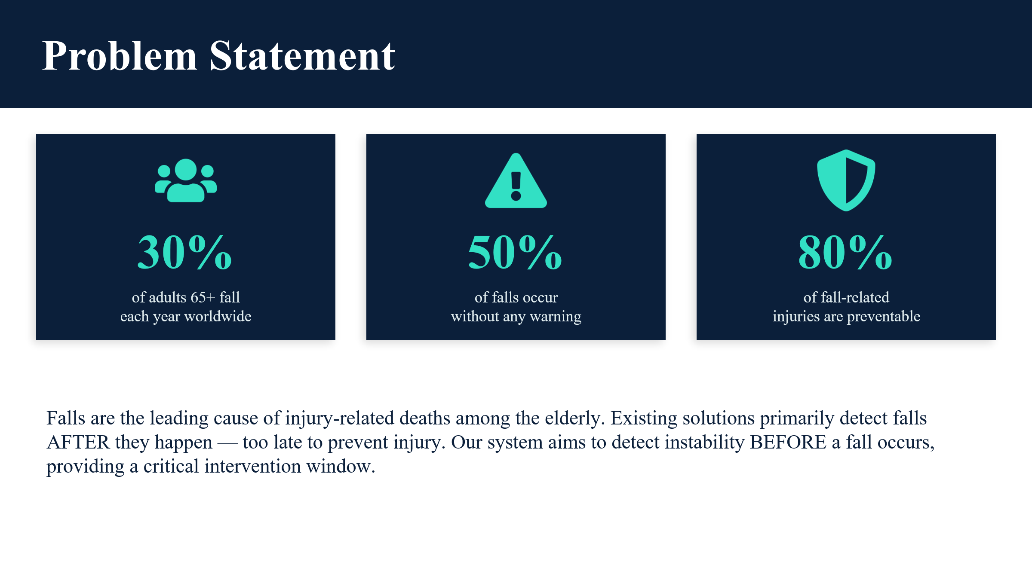
“Approximately 30% of people aged 65 and above experience falls annually.” These are approximate values based on general studies. This highlights how common and serious this issue is in today’s society.
Falls are not just minor incidents; they can lead to severe injuries such as fractures, head trauma, and long-term health complications. In many cases, the real danger is not the fall itself, but the delay in receiving medical assistance. When a person is alone, especially in a home environment, a fall may go unnoticed for a long time, which can worsen the situation significantly.
Another major concern is that many elderly individuals prefer independent living, where continuous supervision is not possible. Family members or caregivers cannot monitor them 24/7, which increases the risk during emergency situations. Existing solutions, such as wearable devices, are not always reliable. Users may forget to wear them, or the devices may fail due to battery issues. Moreover, these solutions are not very comfortable for long-term use, especially for elderly people.
There is also a lack of intelligent and automated monitoring systems that can detect falls in real time and respond immediately. Most traditional systems do not provide instant alerts or proper data tracking, making them less effective in critical situations.
Furthermore, many existing systems lack intelligent decision-making and real-time response capabilities. They may not provide immediate alerts or may generate false alarms, leading to confusion and inefficiency. There is also a lack of proper data storage and monitoring systems that can help track past incidents and analyze patterns over time.
Therefore, there is a strong need for a smart, automated, and non-intrusive system that can continuously monitor a person, detect falls accurately, and provide immediate alerts to ensure safety and quick response. Such a system should be reliable, efficient, and easy to use, making it suitable for real-world applications such as homes, hospitals, and elderly care centers.

1.5 Identification/Reorganization of need
The purpose of the proposed system is to design an AI based solution for detecting human falls and assessing fall risk in real time. The system aims to provide timely alerts in case of accidental falls, especially for elderly individuals who may be living alone or without immediate assistance. The system helps in reducing the response time during emergency situations and improving personal safety using computer vision and artificial intelligence techniques. The proposed system focuses on a non-intrusive, camera-based approach that eliminates the need for wearable devices. In order to identify unusual behaviour and possible fall hazards, it examines human posture and movement patterns. The system is designed to operate efficiently while maintaining user privacy through local processing and minimal data storage. Furthermore, the proposed system also aims to incorporate early risk prediction capabilities by analyzing instability patterns, sudden posture changes, and abnormal movement behaviour before an actual fall occurs. This proactive approach makes the system more advanced than traditional fall detection systems that only respond after an incident has already happened. By identifying warning signs in advance, the system can help prevent serious injuries and provide preventive alerts.
In addition, the project emphasizes affordability and accessibility so that it can be implemented in regular households without requiring expensive infrastructure. Since the system is designed to work on a standard laptop with a basic camera setup, it ensures ease of deployment and practical usability. The solution is scalable and can be further integrated with mobile notifications, alarm systems, or smart home technologies in the future.
The project also contributes to the growing field of artificial intelligence in healthcare by demonstrating how computer vision can be effectively used for real-life safety applications. It provides a foundation for future research and development in intelligent monitoring systems. By combining innovation, practicality, and social impact, the proposed system aims to create a safer living environment for vulnerable individuals while supporting caregivers with reliable and automated assistance.
The project also focuses on maintaining user privacy. Instead of storing clear images, the system saves blurred images of detected events, ensuring that personal identity is protected while still maintaining useful records. This makes the system more acceptable for use in sensitive environments such as homes and healthcare facilities.
In addition, the system includes a dashboard that provides real-time monitoring and displays important information such as live status, total fall count, alerts, and event history. This allows users to easily track and analyze data, making the system more interactive and user-friendly.
In addition to providing real-time monitoring and alert mechanisms, the system is also designed to be flexible and adaptable for different environments. It can be used not only in homes but also in hospitals, rehabilitation centers, and elderly care facilities where continuous patient monitoring is required.
Another important purpose of this project is to reduce the dependency on human supervision. By automating the process of monitoring and fall detection, the system helps caregivers focus on other important tasks while still ensuring that the safety of individuals is not compromised. This can significantly reduce the workload on healthcare staff and improve overall efficiency in caregiving environments.
The system also aims to promote independent living among elderly individuals. By providing a reliable monitoring solution, it allows them to live more confidently without the constant need for supervision. This not only improves their quality of life but also reduces the emotional stress on family members who are concerned about their safety.
Furthermore, the project focuses on building a foundation for future advancements in smart healthcare systems. The current implementation can be extended with additional features such as mobile application integration, remote monitoring, and advanced analytics. These enhancements can further improve the system’s functionality and make it more intelligent and user-friendly.
Another purpose of the project is to create awareness about the use of technology in solving real-life problems. It demonstrates how computer vision and simple logic-based approaches can be used to build effective and practical solutions without the need for complex hardware or expensive infrastructure. This encourages the adoption of innovative technologies in the healthcare domain.
In conclusion, the purpose of this project extends beyond just fall detection. It aims to provide a comprehensive, reliable, and scalable solution that enhances safety, supports independence, reduces workload, and contributes to the development of smarter and more efficient healthcare systems.

1.6 Existing System
Currently, fall detection systems are mainly based on wearable devices, sensor-based equipment, or manual emergency alert mechanisms. Many elderly individuals use smart bands, pendants, or wrist-worn devices that contain accelerometers and gyroscopic sensors to detect sudden movements. These devices trigger an alert when abnormal motion is detected. Some systems also require the user to manually press an emergency button after a fall.
In addition to wearable devices, certain monitoring systems use motion sensors, floor pressure sensors, or infrared sensors installed inside homes. These systems detect sudden changes in movement or inactivity over a long period of time. Advanced surveillance-based systems also use CCTV cameras, but they may store video data in cloud servers, which raises privacy concerns.
However, the existing systems have several limitations:
- Users often forget to wear wearable devices regularly.
- Wearable systems may cause discomfort or inconvenience.
- Manual emergency buttons cannot be used if the person becomes unconscious.
- Sensor-based systems may generate false alarms due to sudden but normal movements.
- Many systems detect falls only after they occur and do not provide early risk prediction.
Due to these limitations, there is a need for a more intelligent, accurate, and privacy-aware fall detection system that works efficiently without depending on wearable devices.

Disadvantages of Existing System:-
- Depend heavily on wearable devices which may be uncomfortable or forgotten by users
- Require continuous human supervision in some cases
- Generate false alarms due to inaccurate motion detection
- High cost of specialized hardware and maintenance
- Limited accuracy in real-time fall detection

1.7 Proposed System
The proposed system is an AI-based intelligent vision system designed to detect human falls and predict potential fall risks using real-time video analysis. Unlike traditional wearable or sensor-based systems, this system uses computer vision and machine learning techniques to analyze human posture and body movements through a standard camera.
The proposed system works by capturing video input and applying pose estimation techniques to detect key body points such as joints and limb positions. By analyzing posture patterns and movement dynamics, the system can identify sudden falls as well as unstable movements that indicate a high risk of falling. This makes the system proactive rather than reactive.
Key features of the proposed system include:
- Real-time fall detection using computer vision
- Early risk prediction by analyzing instability and imbalance
- Non-intrusive monitoring without wearable devices
- Immediate alert generation during emergency situations
- Local data processing to maintain user privacy
- Affordable implementation using a standard laptop and built-in camera
The proposed system aims to minimize false alarms by using machine learning models trained on human activity datasets. It focuses on providing accurate, reliable, and cost-effective monitoring suitable for home environments.
Compared to the existing systems, the proposed system offers better usability, reduced dependency on physical devices, enhanced privacy protection, and improved preventive detection capabilities.
The proposed system is a Smart Fall Detection System designed to monitor human posture in real time and detect falls using computer vision techniques. The system aims to provide a reliable and automated solution for ensuring the safety of elderly individuals and patients without requiring any wearable devices. It operates by capturing video input through a camera and analyzing the posture of a person continuously.
The system uses pose estimation techniques to identify key body landmarks such as the shoulder, hip, and knee. These landmarks are essential for understanding the orientation and movement of the human body. By analyzing the relative positions of these points, the system is able to determine whether the person is standing, bending, or has fallen. This approach makes the system efficient and suitable for real-time applications.
Once the landmarks are detected, the system calculates the angle between specific body points. This angle is used as the primary parameter for determining the posture of the individual. Based on predefined threshold values, the system classifies the posture into three categories: Normal, Warning, and Fall. This classification helps in identifying not only falls but also potential risks before a fall occurs.
The system continuously processes video frames to ensure that any abnormal movement is detected immediately. This real-time processing capability is one of the key strengths of the proposed system, as it allows for quick response during emergency situations. A major component of the proposed system is the implementation of a stability enhancement mechanism. In real-world scenarios, sudden movements or temporary changes in posture can lead to incorrect detections. To address this issue, the system uses multi-frame validation, where multiple consecutive frames are analyzed before confirming a fall. This additional validation step helps in distinguishing between actual falls and temporary postures such as bending or sitting. By combining angle-based detection with persistence checking, the system achieves higher reliability and accuracy. Another important feature of the proposed system is the alert mechanism. When a fall is confirmed, the system triggers a voice alert to notify nearby individuals. In addition, an email alert is sent to caregivers or family members, ensuring that help can be provided even if no one is physically present nearby. This dual alert system enhances the effectiveness of the solution in emergency situations. The system also captures and stores images of detected events. To maintain privacy, these images are blurred before being saved. This ensures that user identity is protected while still providing useful information for analysis and record-keeping. The proposed system also incorporates a database for storing event-related information. Each detected event is recorded along with details such as date, time, status, angle, risk level, recovery status, and alert status. This structured data storage allows users to maintain a complete record of all incidents, which can be useful for monitoring and analysis. To provide easy access to this information, the system includes a web-based dashboard developed using a lightweight web framework... The system can be deployed in various environments such as homes, hospitals, and elderly care centers without requiring complex infrastructure.The proposed system is designed to be flexible and scalable, allowing for future enhancements and modifications. It can be extended to include additional features such as multi-person detection, mobile application integration, and cloud-based data storage. These enhancements can further improve the functionality and usability of the system. Another important aspect of the system is its non-intrusive nature. Unlike wearable devices, the system does not require any physical interaction from the user. This makes it more comfortable and convenient, especially for elderly individuals who may find wearable devices difficult to use. Overall, the proposed system provides a comprehensive solution for fall detection by combining real-time monitoring, accurate detection, stability enhancement, alert mechanisms, data storage, and user-friendly interfaces. It addresses the limitations of existing systems and offers a reliable and efficient approach to improving safety and healthcare monitoring.

1.8 Unique Features of the system
The Smart Fall Detection System includes several important features that make it efficient, reliable, and suitable for real-world applications. One of the key features of the system is real-time fall detection. The system continuously processes video input and analyzes human posture without delay, ensuring that any abnormal activity is detected instantly.
Another important feature is multi-stage classification. The system categorizes human posture into three states: Normal, Warning, and Fall. This approach not only detects falls but also provides early warnings, which can help in preventing accidents.
The system also includes a stability enhancement mechanism. Instead of relying on a single frame, it uses multiple frames to confirm a detected status. This reduces instability and false detections, improving the accuracy and reliability of the system.
In addition, the system features an alert mechanism that includes voice notifications and email alerts. When a fall is detected, the system immediately notifies nearby individuals and caregivers, ensuring a quick response.
Another significant feature of the system is the web-based dashboard. The dashboard provides real-time monitoring and displays important information such as live status, total falls, alerts, and recent events. This allows users to easily track and analyze data.
The system also includes an event logging feature, where all detected events are stored in a database. This enables users to maintain records and analyze patterns over time, which can be useful for improving safety measures.
Privacy protection is another important aspect of the system. To ensure user confidentiality, the system stores blurred images instead of clear visuals. This makes the system suitable for use in sensitive environments such as homes and healthcare facilities.
Furthermore, the system is designed to be lightweight and cost-effective. It does not require expensive hardware or wearable devices, making it accessible and easy to deploy. The use of commonly available technologies ensures that the system can be implemented in various environments.
Overall, these features make the system a comprehensive solution that combines real-time monitoring, accurate detection, alert mechanisms, data storage, and user-friendly interaction into a single platform.
The Smart Fall Detection System is designed with multiple advanced features that make it efficient, reliable, and suitable for real-world applications. One of the most important features of the system is real-time fall detection. The system continuously captures and processes video input, ensuring that any abnormal movement or posture is detected instantly without delay. This real-time capability plays a crucial role in emergency situations, as it helps in reducing response time and enables quick assistance.

Another key feature is the multi-stage classification mechanism, where the system categorizes human posture into three different states: Normal, Warning, and Fall. This approach not only helps in detecting falls but also provides an early indication of instability. The warning stage acts as a preventive measure, allowing timely intervention before a fall actually occurs.
The system also utilizes pose estimation techniques to analyze human posture. By identifying key body landmarks such as the shoulder, hip, and knee, the system calculates angles to understand body orientation. This method is simple, efficient, and suitable for real-time processing, making it a practical choice for fall detection systems.
In addition, the system uses an angle-based detection logic, which allows it to classify different states based on predefined thresholds. This approach ensures fast processing and eliminates the need for complex model training, making the system lightweight and easy to implement.
Another important feature of the system is the stability enhancement mechanism, which is implemented using multi-frame validation. Instead of relying on a single frame, the system checks multiple consecutive frames before confirming a fall. This helps in reducing instability and avoiding false detections caused by sudden movements or noise. As a result, the system becomes more reliable and accurate in real-world scenarios.
The system also includes a smart alert mechanism that ensures immediate response during emergencies. When a fall is detected, the system triggers voice alerts to notify nearby individuals. Additionally, it sends email notifications to caregivers or family members, ensuring that help can be provided quickly even if no one is physically present nearby.
Another key feature is the event logging system, where all detected events are stored in a database along with important details such as date, time, status, and risk level. This feature allows users to maintain records of past incidents and analyze patterns over time. It also helps in improving monitoring and decision-making.
Furthermore, the system provides a web-based dashboard for real-time monitoring. The dashboard displays live status, total fall count, alert information, and recent events. It also includes visual elements such as charts and tables, making it easy to understand and interpret the data. This enhances the overall user experience and usability of the system.
Privacy protection is another essential feature of the system. To ensure user confidentiality, the system stores blurred images instead of clear visuals. This approach maintains privacy while still preserving useful information for analysis and monitoring. It makes the system more acceptable for use in homes, hospitals, and other sensitive environments.
The system is also designed to be non-intrusive, as it does not require users to wear any devices or interact with the system manually. This makes it more convenient, especially for elderly individuals who may find wearable devices uncomfortable or difficult to use.
Overall, these features make the Smart Fall Detection System a comprehensive and practical solution that combines real-time monitoring, accurate detection, efficient alert mechanisms, data storage, and user-friendly interaction into a single integrated platform.

Chapter 2

Requirement Analysis and System Specification

2.1 Feasibility Study
(Technical Feasibility)
The proposed system is technically feasible because it is developed using modern and widely available software technologies such as Python, OpenCV, Flask, SQLite, MediaPipe, HTML, CSS, and JavaScript. These technologies provide strong support for real-time video processing, image analysis, web application development, database management, and emergency alert generation.
The required libraries and frameworks are open-source and easily accessible, which makes system development simpler and more flexible.
The project does not require highly advanced or specialized hardware for implementation. A standard computer system with a webcam is sufficient for capturing video input and running the fall detection algorithms.
The system uses computer vision techniques to analyze body posture and movement patterns in real time. Multi-frame validation techniques are also implemented to improve detection accuracy and reduce false alarms. Since all required tools, software platforms, and programming resources are available and compatible with standard operating systems, the project can be implemented successfully without major technical difficulties.
The proposed system is scalable and can also support future enhancements such as cloud integration, IoT devices, mobile application support, live CCTV monitoring, and AI-based predictive healthcare analysis. Therefore, from a technical perspective, the system is practical, implementable, and suitable for real-world healthcare environments.
(Economical Feasibility)
The proposed system is economically feasible because it is designed using low-cost and open-source technologies, which significantly reduce the overall development and maintenance expenses. Unlike expensive healthcare monitoring systems available in the market, the proposed solution does not require specialized sensors, costly surveillance systems, or commercial software licenses.
Most of the software tools and libraries used in the project are freely available for educational and development purposes. The hardware requirements of the system are also minimal. The project can operate efficiently using a normal computer system and a standard webcam for video capture. Since no advanced medical equipment is required, the implementation cost remains affordable for hospitals, rehabilitation centers, old-age homes, and home healthcare environments.
The low-cost architecture makes the system suitable for both small-scale and large-scale healthcare applications. In addition to low implementation cost, the system can also help reduce expenses related to continuous manual patient monitoring.
Automated fall detection and alert generation reduce the dependency on constant human supervision, thereby improving healthcare efficiency and minimizing operational workload.
The maintenance cost of the system is also comparatively low because software updates and modifications can be performed easily without replacing hardware components. Hence, the project is economically beneficial, practical, and cost-effective.
(Operational Feasibility)
The proposed system is operationally feasible because it is designed to function efficiently in real-world healthcare and patient monitoring environments. The system is fully automated and capable of continuously monitoring patient activities without requiring constant human interaction.
It can detect falls in real time, generate emergency alerts, and store event details automatically, which improves healthcare monitoring and emergency response efficiency.
The system provides a simple and user-friendly web dashboard through which healthcare staff, caregivers, or family members can easily monitor patient status, view analytics, access emergency reports, and track alert history.
The interface is designed to be interactive, visually clear, and easy to understand even for non-technical users. Real-time notifications and emergency banners further improve the operational effectiveness of the system.
The proposed system also supports continuous monitoring, which is highly useful in hospitals, rehabilitation centers, elderly care homes, and smart healthcare environments where manual monitoring may not always be possible.
By providing instant alerts during emergency situations, the system helps reduce response time and improve patient safety. The implementation of privacy protection through blurred image storage also makes the system more acceptable and reliable for practical usage.
Since the system improves healthcare monitoring efficiency, reduces manual workload, enhances patient safety, and operates using simple user interactions, it is considered operationally feasible and suitable for deployment in real-world

2.2 Software and hardware Requirements

Software Requirements:-

Operating System : Windows 10 / 11, Linux, or macOS

Programming Language : Python 3.10

Development Environment : VS Code, Jupyter Notebook

Libraries : OpenCV, MediaPipe, Pandas, NumPy

Dataset : Publicly available fall detection video datasets

Browser : Google Chrome (for testing alerts or dashboards)

Hardware Requirements:-

Processor : Intel i5 or equivalent (minimum i3 supported)

RAM : Minimum 8 GB (4 GB workable for testing)

Camera : In-built laptop camera or external webcam (for demo purpose)

Storage : 20–30 GB free space

2.3 Validation
Validation is one of the most important processes in the proposed Smart Fall Detection System using Computer Vision. The primary purpose of validation is to ensure that the system performs accurately, reliably, and efficiently in real-time environments. Since the project deals with healthcare monitoring and emergency detection, it is essential that the system correctly identifies actual fall events while minimizing false alarms caused by normal human activities such as sitting, bending, lying down, or temporary posture changes.
In real-world healthcare applications, a fall detection system must operate continuously and provide dependable results under different environmental conditions. Incorrect detection may create unnecessary panic, while failure to detect a real fall may lead to serious health risks. Therefore, the proposed system uses a validation mechanism known as Multi-Frame Validation to improve accuracy and system reliability.
Multi-Frame Validation
The proposed system does not immediately classify a person as fallen after detecting a single abnormal posture. Instead, it continuously analyzes multiple consecutive video frames before confirming a fall event. This technique is called multi-frame validation. The purpose of this approach is to avoid false detections caused by temporary movements, camera noise, lighting variations, or short-duration posture changes.
During system execution, live video frames are captured continuously through a camera. Each frame is processed using computer vision techniques to analyze body posture, body angle, and movement patterns. If the detected body posture appears abnormal, the system temporarily considers it as a warning condition. However, the system waits for the abnormal posture to remain consistent for a predefined number of frames before confirming the event as a fall.
This validation process helps distinguish between actual falls and normal daily activities. For example, when a person bends down to pick an object, sits on a chair, or temporarily lies down, the body posture may appear similar to a fall for a short time. Without proper validation, the system may incorrectly generate emergency alerts. Multi-frame validation prevents such false alarms by ensuring that the abnormal posture persists for a sufficient duration before triggering emergency actions.
Validation Process of the Proposed System
The validation process of the system follows multiple stages to improve reliability and performance. Initially, the system captures live video input through a camera. The captured frames are analyzed continuously using computer vision algorithms. Body posture and movement angles are calculated in real time to determine the physical condition of the person.
The system classifies the detected posture into three categories:
- Normal Condition
- Warning Condition
- Fall Condition

When a temporary abnormal posture is detected, the system enters the warning stage. During this stage, the system continuously checks the next frames to verify whether the posture returns to normal or remains abnormal. If the abnormal posture continues consistently for multiple frames, the system confirms the event as a fall.
After confirmation, emergency actions such as voice alerts and email notifications are activated. The event information is stored in the database, and the monitoring dashboard is updated with the latest fall status. This validation mechanism improves the overall reliability and efficiency of the healthcare monitoring system.
Importance of Validation in the Proposed System
Validation plays a critical role in the proposed project because the system is designed for emergency healthcare monitoring. Accurate validation ensures that healthcare staff, caregivers, or family members receive alerts only during genuine emergency situations. This reduces unnecessary interruptions and improves trust in the monitoring system.
Without proper validation, the system may frequently generate false alarms, especially during normal body movements. Excessive false alerts may reduce the practical usefulness of the system and create confusion among users. By implementing multi-frame validation, the proposed system achieves better stability, accuracy, and operational performance.
Validation also improves the adaptability of the system in different real-world conditions. Environmental factors such as lighting changes, camera movement, body orientation, and background variations may affect posture detection. Multi-frame validation helps reduce the impact of these factors by analyzing posture behavior over time instead of relying on a single frame.
Performance Validation
The proposed system was tested under different human activities and monitoring conditions to evaluate its performance. Various body movements such as walking, standing, sitting, bending, lying down, and intentional falling were analyzed during testing. The system successfully differentiated between normal activities and actual fall situations in most test cases.
The implementation of multi-frame validation significantly improved the detection accuracy of the system. Temporary posture changes were ignored unless the abnormal condition persisted continuously. As a result, the number of false alerts was reduced considerably. The system also demonstrated stable real-time performance during continuous monitoring sessions.
The emergency alert mechanism was also validated successfully. Once a fall was confirmed, the system generated voice alerts, displayed emergency notifications, and sent email alerts correctly. The database storage and dashboard updates were also tested to ensure proper recording and monitoring of fall events.
Reliability and Accuracy Validation
The reliability of the proposed system depends on its ability to consistently detect falls while avoiding incorrect classifications. The use of continuous frame analysis increases system reliability because decisions are based on long-duration posture behavior instead of momentary movement patterns.
The accuracy of the system is further improved by analyzing posture angles and maintaining frame counters for validation. The system only confirms a fall when both posture conditions and frame persistence conditions are satisfied. This layered validation process minimizes random errors and improves overall detection precision.
The proposed system demonstrates reliable performance for healthcare monitoring applications where quick emergency response and continuous supervision are essential. The combination of computer vision techniques and multi-frame validation makes the system more practical and suitable for real-world implementation.
Advantages of Multi-Frame Validation
The use of multi-frame validation provides several advantages to the proposed system:
- Reduces false fall detections
- Improves system accuracy
- Prevents unnecessary emergency alerts
- Enhances real-time monitoring reliability
- Supports stable healthcare monitoring
- Improves emergency response efficiency
- Increases user trust in the system
- Handles temporary posture variations effectively
These advantages make the validation mechanism an essential part of the proposed fall detection system.
Conclusion of Validation
The validation process confirms that the proposed Smart Fall Detection System is capable of performing reliable and accurate real-time fall detection using computer vision techniques. The implementation of multi-frame validation significantly improves system performance by reducing false alarms and ensuring accurate emergency detection. The system successfully validates posture behavior over multiple frames before triggering emergency actions, making it suitable for practical healthcare monitoring applications.
Overall, the validation mechanism enhances the reliability, efficiency, and usability of the proposed system and supports its deployment in hospitals, rehabilitation centers, elderly care homes, and smart healthcare environments where continuous patient safety monitoring is required.

2.4 Expected Hurdles
Despite its advantages, the Smart Fall Detection System has certain limitations. One of the main limitations is its dependency on camera placement and angle. The accuracy of detection can be affected if the camera does not capture the full body of the person or if the angle is not appropriate.
Another limitation is the sensitivity to lighting conditions. Poor lighting or shadows can affect the accuracy of pose detection, leading to incorrect results or missed detections.
The system also currently supports only single-person detection. It is not designed to handle multiple individuals simultaneously, which limits its use in crowded environments.
Another limitation is the possibility of false detections. Although multi-frame validation reduces errors, sudden movements or unusual postures may still trigger incorrect classifications. This can lead to unnecessary alerts or confusion.
The system also depends on continuous video input. Any interruption in the video feed, such as camera failure or network issues, can affect the performance of the system. Additionally, the system does not include predictive capabilities. It can detect falls after they occur but cannot predict or prevent them in advance.
Another limitation is that the system may not perform well in highly complex environments, such as crowded areas or situations where objects obstruct the view of the person. This can affect the accuracy of detection.
Despite these limitations, the system provides a strong foundation for further improvement. Future enhancements can address these challenges and improve the overall performance and usability of the system.

2.5 SDLC Model to be used
Waterfall Model
The Software Development Life Cycle (SDLC) model used in the proposed “Smart Fall Detection System using Computer Vision” is the Waterfall Model. The Waterfall Model is one of the most widely used and systematic software development models in which the development process follows a sequential step-by-step approach. In this model, each phase is completed before moving to the next phase, ensuring proper planning, documentation, implementation, and testing of the system.
The Waterfall Model is suitable for this project because the system requirements, objectives, and functionalities were clearly identified before the development process started. The project follows a structured flow including requirement analysis, system design, implementation, testing, deployment, and maintenance. Since each stage of development depends on the successful completion of the previous stage, the Waterfall Model provides better organization and easier project management.
The development of the proposed system was carried out through the following phases of the Waterfall Model:

1. Requirement Analysis Phase
In this phase, the problem related to elderly and patient fall monitoring was studied carefully. The system requirements, objectives, hardware requirements, software requirements, and healthcare monitoring needs were identified. Information regarding real-time fall detection, emergency alerts, dashboard monitoring, and database storage was collected and analyzed. The feasibility of the project was also evaluated during this phase.
2. System Design Phase
After requirement analysis, the complete structure and architecture of the proposed system were designed. The system workflow, user interface design, database structure, and fall detection methodology were planned. Flowcharts, working diagrams, and dashboard layouts were prepared to define how different modules of the system would interact with each other. The technologies and tools required for implementation were also finalized during this phase.
3. Implementation Phase
In the implementation phase, the actual coding and development of the system were performed. Python programming language was used for developing the fall detection logic and backend processing. OpenCV and MediaPipe libraries were used for computer vision and posture analysis. Flask was used to develop the web-based dashboard, while SQLite was used for database management. Features such as real-time monitoring, emergency alerts, analytics, reports, and image storage were implemented successfully.
4. Testing Phase
After implementation, the system was tested under different conditions to verify its performance and accuracy. Various activities such as walking, standing, sitting, bending, and falling were tested to evaluate the effectiveness of the fall detection system. Multi-frame validation was also tested to reduce false detections. The emergency alert system, dashboard updates, analytics page, and reports page were checked to ensure proper functionality and reliability.
5. Deployment Phase
Once testing was completed successfully, the system was prepared for practical usage. The developed project can be deployed in hospitals, rehabilitation centers, elderly care homes, and smart healthcare environments for real-time patient monitoring and emergency response. The deployment phase ensures that the system is ready for operational use in healthcare applications.
6. Maintenance Phase
The maintenance phase includes updating, improving, and monitoring the system after deployment. Any future modifications, bug fixes, performance improvements, or feature enhancements can be performed during this stage. Additional functionalities such as cloud monitoring, IoT integration, mobile application support, and AI-based healthcare analysis can also be added in future versions of the system.
Conclusion
The Waterfall Model proved to be an effective SDLC approach for developing the proposed Smart Fall Detection System using Computer Vision. The sequential development methodology helped in proper planning, systematic implementation, accurate testing, and successful deployment of the system. The use of the Waterfall Model ensured organized project development and contributed to the reliability, efficiency, and successful completion of the healthcare monitoring system.
Chapter 3

SYSTEM DESIGN

3.1 Design Approach

Object-Oriented Approach
The proposed Smart Fall Detection System using Computer Vision follows the Object-Oriented Design Approach for system development. In this approach, the system is designed using objects, classes, functions, and modules that interact with each other to perform different tasks efficiently. The Object-Oriented Approach helps in developing a modular, organized, reusable, and easy-to-maintain system.
In the proposed project, different modules such as fall detection, alert generation, database management, dashboard monitoring, analytics, and report generation are implemented separately to improve system structure and functionality. Each module performs a specific task and communicates with other modules when required. This improves code readability, reduces complexity, and simplifies debugging and future modifications.
The Object-Oriented Approach also supports scalability and flexibility. New features such as mobile notifications, cloud monitoring, IoT integration, and advanced AI models can be added easily in future versions of the system without affecting the existing structure. Therefore, the use of the Object-Oriented Approach makes the proposed system more efficient, maintainable, and suitable for real-time healthcare monitoring applications.

3.2 Detail Design
The methodology of the proposed AI-Based Fall Detection and Early Risk Assessment System explains the step-by-step working process of the system. The system is designed to monitor human posture using a camera, analyze body movements using computer vision techniques, and detect fall incidents or predict potential fall risks in real time.
The methodology of the Smart Fall Detection System is based on real-time video processing and posture analysis using computer vision techniques. The system follows a structured approach that includes video acquisition, pose detection, angle calculation, classification, and alert generation. Each step is designed to ensure accurate detection and efficient performance in real-world conditions.
The first step in the methodology is video acquisition, where a camera is used to capture continuous video input. The video is processed frame by frame to enable real-time analysis. Each frame is converted into a suitable format for further processing. This step ensures that the system has a constant stream of data for monitoring human posture.
The next step involves pose detection using MediaPipe, which identifies key body landmarks such as the shoulder, hip, and knee. These landmarks provide essential information about the position and orientation of the human body. The system extracts the coordinates of these points and uses them for further analysis.
Once the landmarks are detected, the system performs angle calculation. It calculates the angle between the shoulder, hip, and knee points to determine the posture of the individual. This angle serves as the primary parameter for identifying whether the person is standing, bending, or lying down.
After calculating the angle, the system proceeds to the classification stage, where the posture is categorized into three states: Normal, Warning, and Fall. This classification is based on predefined threshold values. For example, a higher angle indicates a normal standing position, while a lower angle may indicate a fall. The warning state represents a transition phase where the person may be at risk of falling.
To improve accuracy, the system implements a multi-frame validation mechanism. Instead of relying on a single frame, it analyzes multiple consecutive frames before confirming a result. This helps in reducing false detections caused by sudden movements or temporary posture changes.
This combination of angle-based classification, multi-frame validation, and persistence checking ensures that the system provides reliable and consistent results in real-time scenarios.
Another important component of the methodology is the fall persistence check. The system verifies whether the person remains in a fallen position for a certain number of frames. This ensures that temporary actions such as bending or sitting are not incorrectly classified as falls.
Once a fall is confirmed, the system activates the alert mechanism. This includes generating a voice alert to notify nearby individuals and sending an email notification to caregivers or family members. The alerts are triggered only after the fall is confirmed to avoid unnecessary notifications. This ensures that the system responds effectively during emergencies.
At the same time, the system performs event recording and storage. It captures an image of the detected fall event and applies a blur effect to maintain privacy. The system then stores important details such as date, time, status, angle, risk level, recovery status, and alert status in a database. The stored data is used for monitoring and analysis. The system includes a web-based dashboard that displays real-time status and event history. Users can view information such as total falls, alerts, and recent events, which helps in understanding system performance and identifying patterns.
This integration of detection, alerting, and data storage makes the system more comprehensive and user-friendly.
Overall, the methodology combines multiple techniques, including video processing, pose estimation, angle-based classification, stability enhancement, alert generation, and data visualization. This structured approach ensures that the system is accurate, reliable, and suitable for real-world applications.

3.3 System Design Tools
The working of the system can be explained in the following steps:
1. The camera continuously captures live video.
2. The video is converted into frames.
3. Each frame is processed using OpenCV.
4. MediaPipe detects body key points.
5. The system calculates posture angles and movement speed.
6. The algorithm compares values with fall detection thresholds.
7. If abnormal posture or sudden collapse is detected, the system classifies it as a fall.
8. An alert is generated immediately.
This process runs continuously in real time to ensure instant detection.

3.4 User Interface Design
User Interface Design is one of the most important parts of the proposed Smart Fall Detection System because it allows users to interact with the system easily and efficiently. The proposed system provides a simple, user-friendly, and visually interactive interface for real-time monitoring, emergency management, analytics visualization, and report analysis. The interface of the system is designed using HTML, CSS, JavaScript, and Flask technologies to provide smooth navigation and better user experience.
The main dashboard of the system displays important monitoring information such as live fall status, total fall count, recovery status, alert notifications, and emergency event records. Different color indicators are used to represent normal, warning, and fall conditions so that users can quickly identify the current patient status. The dashboard also contains emergency alert popups and monitoring indicators to improve emergency response efficiency.
The Analytics page provides graphical representation of fall detection data using charts and visualization techniques. It helps users analyze the number of fall events, monitoring activity, and emergency trends in a simple and understandable format. The graphical interface improves data interpretation and helps in healthcare monitoring analysis.
The Reports page displays detailed emergency event records including date, time, fall status, posture angle, risk level, recovery condition, and alert information. This page helps healthcare staff and caregivers maintain proper records of patient activities and emergency incidents for future analysis and monitoring.
The interface is designed using a modern dark theme with glowing effects, responsive buttons, animated alerts, and organized layouts to improve visual appearance and usability. Overall, the user interface design makes the system more interactive, efficient, and suitable for real-time healthcare monitoring applications.

3.5 Database Design
Database Design is an important part of the proposed system because it is responsible for storing, managing, and retrieving healthcare monitoring records efficiently. The proposed Smart Fall Detection System uses SQLite database for maintaining all emergency event information and monitoring data. SQLite is selected because it is lightweight, simple to use, efficient, and suitable for small and medium-scale applications.
The database stores important information related to fall detection events such as date, time, posture status, body angle, risk level, recovery condition, alert status, and image path. Whenever a fall is detected and confirmed by the system, the event details are automatically stored in the database for future monitoring and analysis.
The database design helps maintain proper historical records of detected falls and emergency alerts. These records can later be accessed through the dashboard, analytics page, and reports page. The use of database storage improves data management, monitoring accuracy, and system reliability.
The database structure is designed in a simple and organized manner so that data insertion, retrieval, updating, and management operations can be performed efficiently. Proper database design also helps reduce redundancy and supports smooth communication between the monitoring system and web dashboard.

3.5.1 ER Diagram
An ER (Entity Relationship) Diagram is a graphical representation of the database structure used in the proposed system. It helps visualize the entities, attributes, and relationships involved in database management. The ER diagram of the proposed Smart Fall Detection System represents how healthcare monitoring data is organized and stored in the database.
The main entity used in the system is the “Event” entity, which stores all information related to fall detection incidents. The attributes associated with this entity include:
Event ID
Date
Time
Status
Angle
Risk Level
Recovery Status
Alert Status
Image Path
The ER diagram helps in understanding how different event records are maintained within the database structure. It also improves database planning, management, and implementation. The diagram provides a clear representation of how monitoring information is stored and accessed by the system.

3.5.2 Database Connection Controls and Strings
Database Connection Controls and Strings define how the proposed system establishes communication between the Python application and the SQLite database.
The system uses the sqlite3 library of Python to create and manage database connections efficiently.
Whenever the system starts, a database connection is established automatically. The connection allows the system to insert new emergency records, retrieve previous event data, update monitoring information, and manage healthcare records efficiently.
The following connection string is used in the proposed system:
import sqlite3
conn = sqlite3.connect("fall_detection.db")
cursor = conn.cursor()
In this connection process:
sqlite3.connect() is used to connect the Python application with the SQLite database.
cursor() is used to execute SQL queries such as insert, update, select, and delete operations.
The database connection controls ensure smooth communication between the backend processing system and the database storage system. These controls help the system manage real-time emergency records efficiently and support reliable monitoring and reporting operations.
The use of SQLite database connectivity provides simple implementation, low resource usage, and efficient data handling for the proposed healthcare monitoring system.

3.6 Methodology of System
The working of the system can be explained in the following steps:
1. The camera continuously captures live video.
2. The video is converted into frames.
3. Each frame is processed using OpenCV.
4. MediaPipe detects body key points.
5. The system calculates posture angles and movement speed.
6. The algorithm compares values with fall detection thresholds.

7. If abnormal posture or sudden collapse is detected, the system classifies it as a fall.
8. An alert is generated immediately.
This process runs continuously in real time to ensure instant detection.

Algorithms Used
The project uses a rule-based logic combined with machine learning concepts.
Basic Algorithm Steps:
- Detect human pose key points
- Calculate body inclination angle
- Measure sudden vertical movement
- Compare movement with predefined threshold
- If threshold exceeded → Fall Detected
- Alert Generate

Chapter 4

IMPLEMENTATION, TESTING AND MAINTENANCE

4.1 Languages, IDE’s, Tools and Technologies Used

1. Python
Python is used as the core programming language for this project. It supports a wide range of libraries for AI and machine learning, making development faster and more efficient. Python also provides easy integration with computer vision tools.
2. Machine Learning
Machine learning is used to analyze movement patterns and classify human activities. It helps the system distinguish between normal movements and fall-related actions. This improves prediction accuracy over time.
3. Computer Vision
Computer vision enables the system to interpret visual data from video input. It helps in understanding posture, motion, and abnormal behaviour. This technology is essential for real-time fall detection.
4. OpenCV
OpenCV is used for capturing video input and extracting frames from the camera feed. It also performs basic image processing operations required before analysis. OpenCV ensures smooth and efficient video handling.
5. MediaPipe
MediaPipe is used for human pose estimation by detecting body key points such as joints. It converts human motion into skeletal data for analysis. This helps reduce privacy issues by avoiding identity recognition.
6. NumPy
NumPy is used for performing numerical calculations and handling large data arrays. It improves processing speed and efficiency during feature extraction.
7. Pandas
Pandas is used for organizing, cleaning, and managing data in a structured format. It helps in handling datasets efficiently and simplifies data analysis tasks. Pandas improves overall data handling accuracy.

8. TensorFlow / PyTorch
These frameworks are used to build and train machine learning models. They provide support for deep learning and model optimization. The frameworks help in improving detection accuracy and performance.
9. Jupyter Notebook
Jupyter Notebook is used for experimentation, testing, and visualization of results. It allows easy analysis of outputs during development. This helps in debugging and improving the model.
10. VS Code
VS Code is used as the primary development environment. It provides tools for debugging, code management, and version control. This improves coding efficiency and project organization.

4.2 Testing Techniques and Test Plans
Testing is an important phase of the proposed Smart Fall Detection System using Computer Vision because it helps verify whether the system is functioning correctly, accurately, and efficiently in real-time environments. The testing process ensures that all modules of the system such as fall detection, emergency alerts, dashboard monitoring, database storage, analytics visualization, and reports generation work properly without errors.
The proposed system was tested under different monitoring conditions and human activities to evaluate its performance and reliability. Various body movements such as walking, standing, sitting, bending, lying down, and intentional falling were analyzed during testing. The system successfully differentiated between normal activities and actual fall situations using posture analysis and multi-frame validation techniques.
Different testing techniques were used in the proposed project to ensure proper functionality of the system. Real-time testing was performed to check whether the system could detect falls continuously from live video input. Alert testing was carried out to verify that emergency voice alerts and email notifications were generated correctly after fall confirmation. Database testing was also performed to ensure that event records such as date, time, status, angle, risk level, and alert details were stored properly in the SQLite database.
The dashboard, analytics page, and reports page were tested to confirm that monitoring information, charts, emergency notifications, and historical records were displayed correctly. The system was also tested under different lighting conditions and movement patterns to improve detection accuracy and reduce false alarms.
The test plan of the proposed system included the following major tests:
- Fall Detection Testing
- Normal Activity Testing
- Warning Detection Testing
- Emergency Alert Testing
- Database Storage Testing
- Dashboard and Analytics Testing
- Reports Page Testing
- Real-Time Monitoring Testing
Overall, the testing process confirmed that the proposed Smart Fall Detection System is stable, reliable, and suitable for healthcare monitoring applications such as elderly care, patient safety monitoring, rehabilitation centers, and smart healthcare environments.

Chapter 5

RESULTS & DISCUSSIONS

5.1 User Interface Representation
The proposed Smart Fall Detection System provides a user-friendly and interactive interface for real-time healthcare monitoring and emergency management.
The interface is designed using HTML, CSS, JavaScript, and Flask technologies to provide smooth navigation, visual clarity, and efficient monitoring of patient activities.
The system interface includes multiple modules such as the dashboard, analytics page, emergency reports page, and alert notification system. These modules help users monitor fall events, analyze healthcare data, and manage emergency situations efficiently.
The interface is designed using a modern dark theme, glowing effects, organized layouts, and responsive components to improve usability and user experience.
The dashboard displays real-time monitoring status, total fall count, recovery information, emergency alerts, and event records. The analytics page provides graphical representation of fall detection data for better analysis and visualization.
The reports page stores detailed emergency event information, while the alert system generates emergency notifications during fall incidents.
The user interface improves system accessibility and allows healthcare staff, caregivers, and users to interact with the monitoring system easily and effectively.
The graphical analytics section improves data interpretation and helps users understand monitoring statistics easily.
Charts and visual representations make the system more interactive and support healthcare monitoring analysis in a simple and understandable format.
The user interface improves system accessibility and allows healthcare staff, caregivers, and users to interact with the monitoring system easily and effectively.
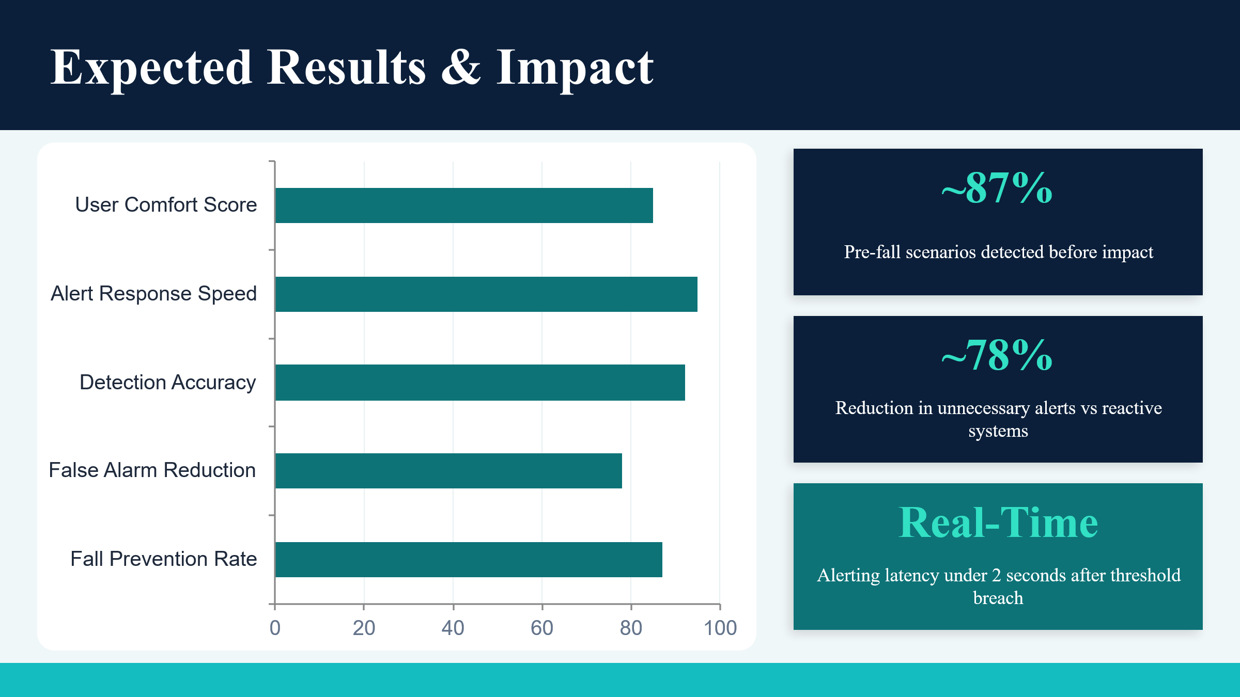

This graph shows that around 87% pre-fall scenarios detected before impact. And around 78% reduction in unnecessary alerts vs reactive systems.
Alerts latency under 2 seconds after threshold breach.
5.2 Snapshots of system
This section contains screenshots of the developed Smart Fall Detection System along with brief explanations of each interface. The snapshots help demonstrate the practical implementation and working of the proposed system.
The following snapshots can be included in this section:
Main Dashboard Interface
Live Monitoring Screen
Analytics Page
Emergency Reports Page
Emergency Alert Popup
Database Storage Records
Each screenshot should include a small description explaining the functionality and purpose of the displayed interface. The snapshots provide visual understanding of the developed system and help represent the practical working of the project.

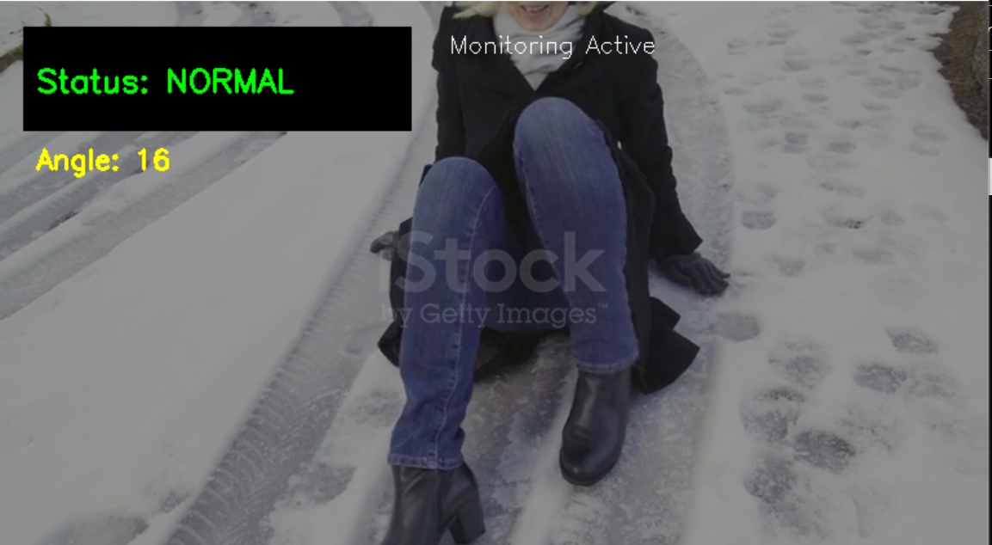
If there is normal fall no alert sent.
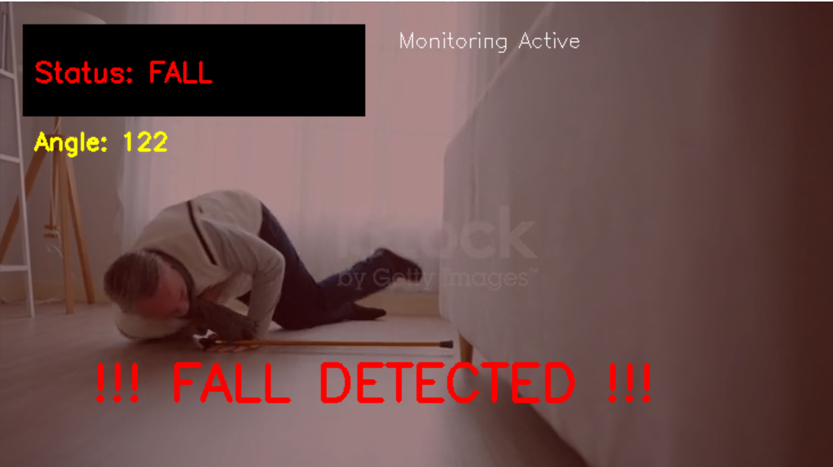
If fall is not normal it generates a voice alert “Emergency! Please stabilize yourself”’. If no recovery detected it sent email to their family members to prevent injuries.
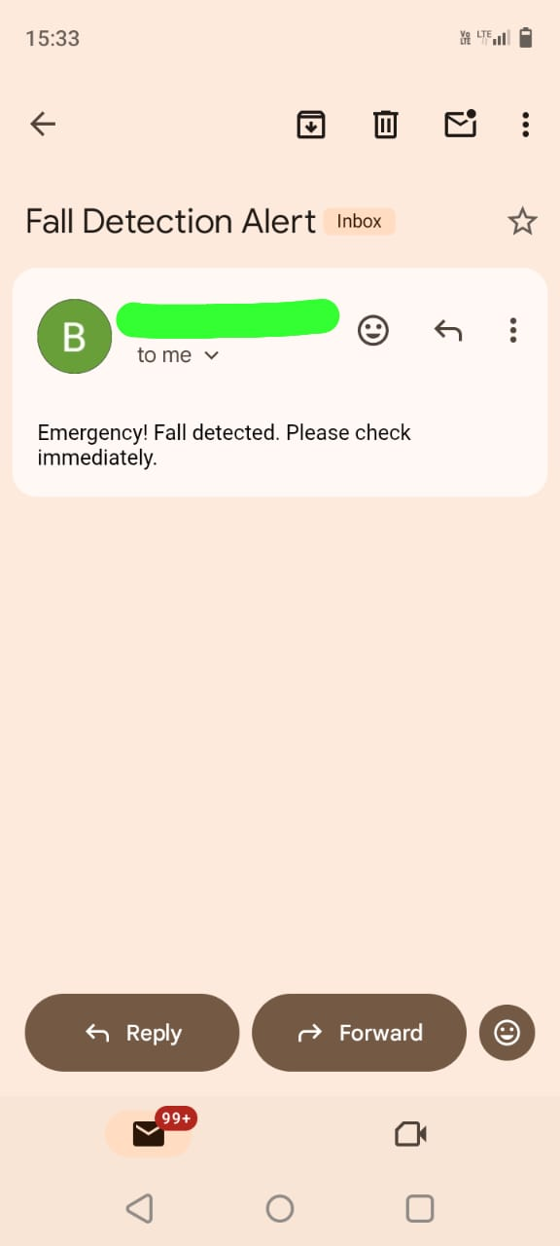
Email sent Successfully!
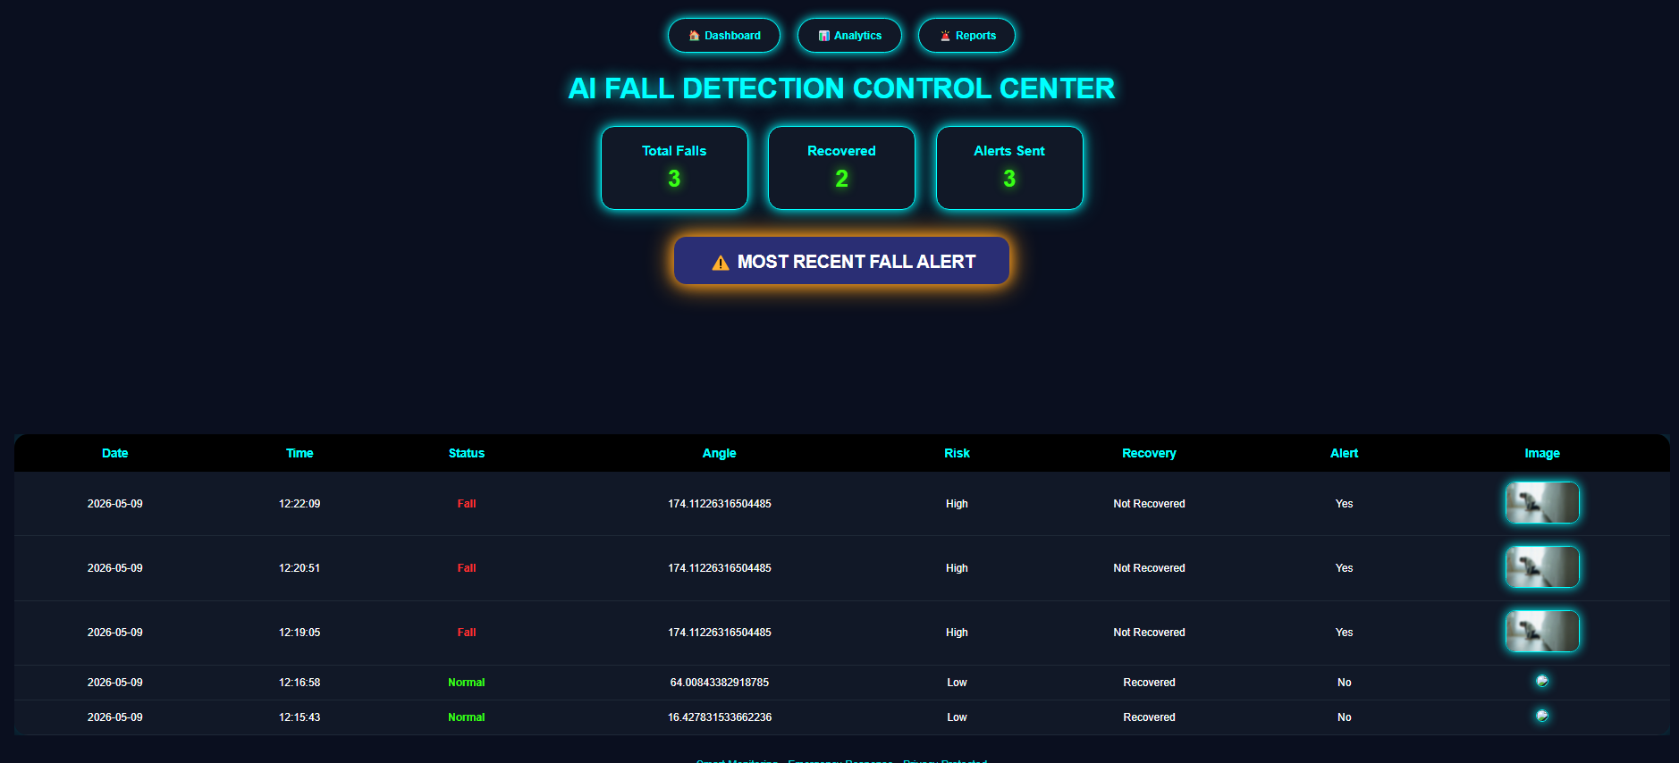

“This dashboard provides real-time monitoring of the system. It shows the current status of the person as SAFE or DANGER, along with total fall count and alerts. All events are stored and displayed in a table with timestamps and images. Additionally, graphical representation helps in quick analysis.”

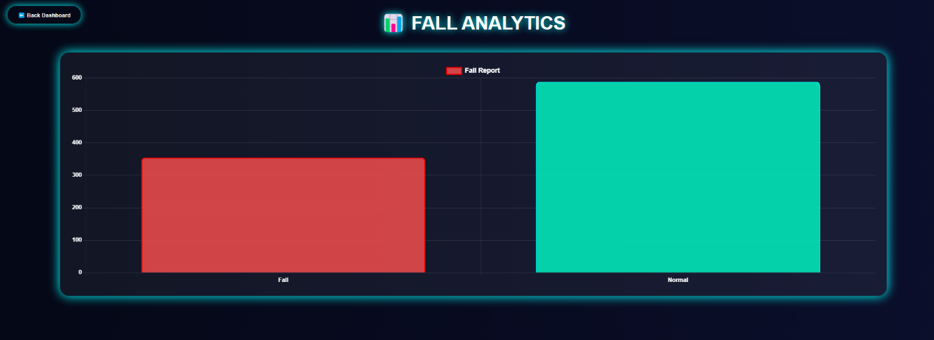

The Analytics Dashboard provides a visual representation of fall detection events, enabling
Quick monitoring and analysis of patient activity.

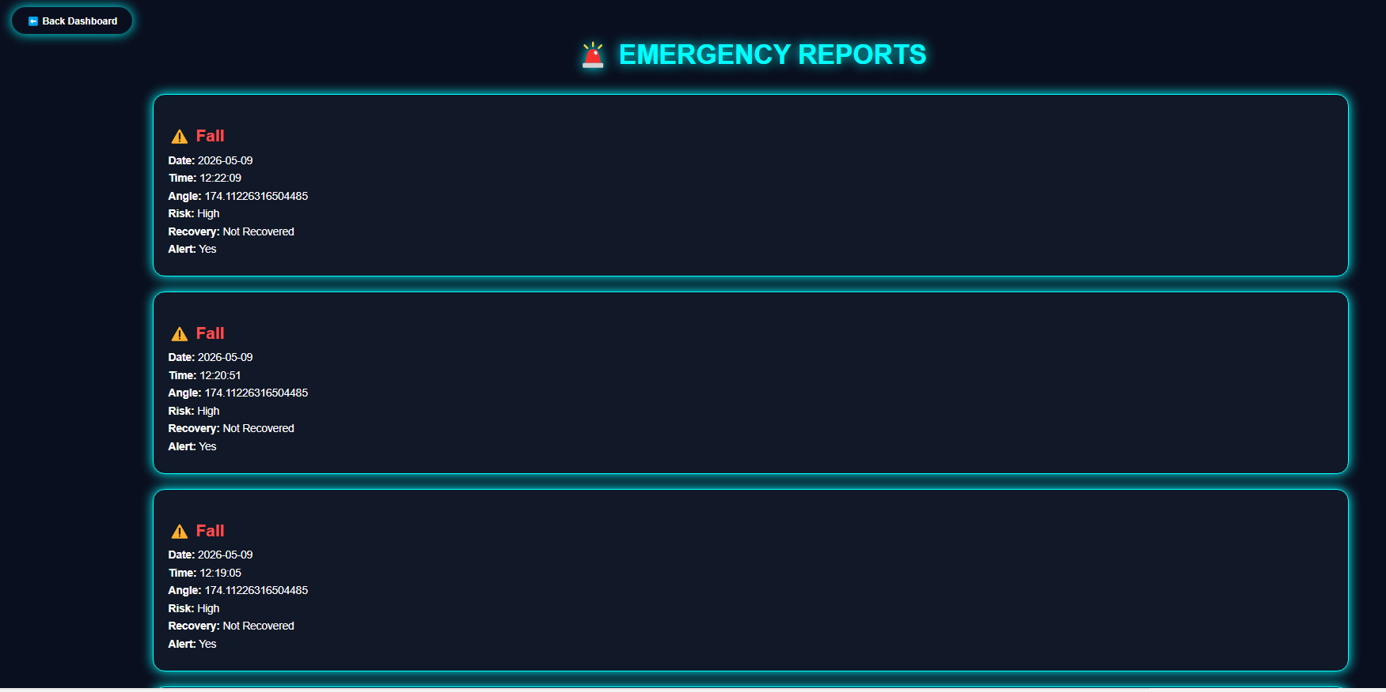

The Emergency reports page displays detailed records of detected fall incidents, including risk level, recovery status, alert response, and event timing for efficient emergency tracking.

Chapter 6

Conclusion and future scope

6.1 Conclusion
The proposed AI-Based Fall Detection and Early Risk Assessment System provides a smart and efficient solution for monitoring human safety. By combining computer vision and intelligent movement analysis, the system detects falls in real time and generates immediate alerts. The project demonstrates how artificial intelligence can enhance personal safety and reduce risks in emergency situations. The system is cost-effective, easy to deploy, and suitable for home environments.
In today’s rapidly evolving world, ensuring the safety and well-being of elderly individuals and patients has become a major concern. Falls are one of the leading causes of injury among elderly people, and the lack of immediate assistance can significantly increase the severity of such incidents. This project, titled Smart Fall Detection System using Computer Vision, presents a practical and effective solution to this problem by utilizing modern technology for real-time monitoring and emergency response.
The system successfully demonstrates how computer vision techniques can be used to analyze human posture and detect falls accurately. By using pose estimation and angle-based logic, the system is able to classify human states into Normal, Warning, and Fall categories. This multi-stage classification not only helps in detecting falls but also provides early warnings, which can play a crucial role in preventing accidents.
One of the major strengths of this system is its ability to operate in real time. The continuous processing of video frames ensures that any abnormal activity is detected instantly, reducing the response time during emergencies. The integration of alert mechanisms such as voice notifications and email alerts further enhances the effectiveness of the system by ensuring that help can be provided quickly.
Additionally, the system includes a database and dashboard for storing and visualizing event data. This feature allows users to monitor real-time status and analyze past incidents, making the system more interactive and informative. The use of blurred image storage also ensures that user privacy is maintained, which is an important consideration in healthcare applications.
Another important aspect of this project is its simplicity and cost-effectiveness. Unlike many existing solutions that rely on wearable devices or expensive hardware, this system uses a camera-based approach, making it more accessible and easy to deploy. The use of widely available technologies such as Python, OpenCV, and Flask ensures that the system can be implemented without significant cost or complexity.
The project also highlights the importance of stability in real-time detection systems. By implementing multi-frame validation, the system reduces instability and false detections, resulting in more reliable performance. This improvement enhances user trust and makes the system more suitable for practical applications.
Although the system has certain limitations, it provides a strong foundation for further development and improvement. It demonstrates how a simple yet effective approach can be used to solve real-world problems and improve safety. The project successfully combines multiple components such as video processing, decision-making, alert systems, and data visualization into a single integrated platform.
In conclusion, the Smart Fall Detection System using computer vision provides an effective and practical solution to address the critical issue of fall detection among elderly individuals and patients. Falls are a major concern due to their potential to cause serious injuries and complications, especially when immediate assistance is not available. This project successfully demonstrates how modern technology can be utilized to improve safety and reduce risks in real-world scenarios.
The system is capable of monitoring human posture in real time, detecting abnormal movements, and identifying falls accurately. By using pose estimation and angle-based logic, it classifies the human state into Normal, Warning, and Fall, providing both detection and prevention capabilities. The inclusion of stability enhancement further improves the reliability of the system by reducing false detections.
Additionally, the system maintains user privacy through blurred image storage and does not require wearable devices, making it non-intrusive and convenient. Its cost-effectiveness and simplicity make it suitable for deployment in various environments such as homes, hospitals, and elderly care centers.
Overall, this project provides a reliable, efficient, and scalable solution that enhances safety, supports independent living, and contributes to the development of smart healthcare systems.

6.2 Future Scope
Although the proposed system performs effectively in detecting falls and providing alerts, there are several opportunities for improvement and expansion in the future. One of the most significant enhancements is the integration of live camera systems such as CCTV or IP cameras. This would allow the system to monitor real-time environments continuously, making it more practical for deployment in homes, hospitals, and public spaces.
Another important area of development is the creation of a mobile application that can provide instant notifications to caregivers and family members. Instead of relying only on email alerts, mobile-based notifications can ensure faster communication and better accessibility. This would make the system more user-friendly and efficient in emergency situations.
The system can also be integrated with IoT devices such as alarms, buzzers, or smart home systems. These devices can automatically trigger loud alerts or activate emergency protocols when a fall is detected. This integration would enhance the effectiveness of the system and provide an additional layer of safety.
In addition, the system can be improved by incorporating advanced algorithms for better accuracy and performance. Although the current system uses a rule-based approach, future versions can include more intelligent techniques to handle complex scenarios and reduce false detections.
Another important enhancement is the implementation of multi-person detection and tracking. Currently, the system is designed to monitor a single individual, but extending it to handle multiple people simultaneously would make it suitable for use in hospitals, elderly care centers, and crowded environments.
Cloud integration is also a valuable addition to the system. By storing data on cloud platforms, users can access information from anywhere and perform advanced analysis. This would enable remote monitoring and centralized data management, making the system more scalable and efficient.
Furthermore, the system can be enhanced with predictive capabilities, where it not only detects falls but also predicts the likelihood of a fall based on posture and movement patterns. This proactive approach can help in preventing accidents before they occur. Another area of improvement is user interface design. Enhancing the dashboard with more interactive features and better visualization tools can improve the overall user experience. Additionally, voice assistant integration can be added to make the system more accessible for elderly users.
In the future, this system can evolve into a complete smart healthcare solution that integrates monitoring, prediction, and response mechanisms. With continuous development and innovation, it has the potential to make a significant impact in improving safety and healthcare services.
Although the Smart Fall Detection System performs effectively, there are several opportunities for further improvement and expansion in the future. One of the major enhancements is the integration of live camera systems such as CCTV or IP cameras, which would enable real-time monitoring in various environments such as homes, hospitals, and public spaces.
The system can also be integrated with IoT devices such as alarms, buzzers, and smart home systems. These devices can automatically trigger alerts or emergency responses when a fall is detected, further enhancing safety.
Future improvements can also focus on increasing accuracy by using advanced algorithms and improving detection capabilities in complex scenarios. Additionally, multi-person detection can be implemented to allow the system to monitor multiple individuals simultaneously, making it suitable for large-scale environments.
In the future, the system can also include predictive capabilities, where it can analyze movement patterns and identify potential risks before a fall occurs. Overall, these enhancements can transform the system into a more advanced and smart healthcare system.

References and Bibliography

1. OpenCV Documentation – Computer Vision Library
Available at: https://opencv.org/
2. Flask Documentation – Python Web Framework
Available at: https://flask.palletsprojects.com/
3. Python Official Documentation
Available at: https://docs.python.org/3/
4. SQLite Documentation – Database Management
Available at: https://www.sqlite.org/docs.html
5. Mediapipe Documentation – Pose Detection Framework
Available at: https://developers.google.com/mediapipe
6. Pyttsx3 Documentation – Text to Speech Library
Available at: https://pyttsx3.readthedocs.io/
7. Research Paper: “Vision-Based Fall Detection Systems for Elderly People”
International Journal of Computer Applications.
8. Research Paper: “Human Fall Detection Using Computer Vision and Machine Learning Techniques”
IEEE Xplore Digital Library.
9. Research Paper: “Real-Time Fall Detection for Elderly Monitoring Systems”
Springer Research Publications.
10. MDN Web Docs – HTML, CSS, and JavaScript Documentation
Available at: https://developer.mozilla.org/

